Name
Instructor
Course
Date
The Village at Gulfstream Park
The Gulfstream Park project employs the use of green architectural practices as embodied by its design which has enabled it to earn a Leadership in Energy and Environmental Design (LEED) accreditation (Zeunert 20). The redevelopment of the site was aimed at complementing the existing use of the projects including the recycling and re-using of existing materials on site such a utilizing demolished concrete as a sub-base for the new surface parking lot. The Gulfstream Park is designed for purposes of creating a vibrant urban environment which takes into account the most pressing needs of pedestrians. This may be evidenced by the fact that the project incorporates pedestrian-oriented streetscapes with buffers that facilitate greater access to businesses. The Village Green which serves as the primary pedestrian area integrates a wide variety of amenities such as decorative paving patterns, kiosk, wide sidewalks, water fountains, benches and wide planter edges.
The Gulfstream Park employs the use of energy saving measures through the purchase renewable energy credits including sub-metering of water usage and the use of weather controlled reuse irrigation system which supplement common area. The project also incorporates the mixture of land uses to facilitate proximity between retail, residential and employment opportunities while availing shared parking for such complexes. Perhaps the most conspicuous form of green practice at Gulfstream Park is forbidding the development of deed and covenant restriction which curtail the development of green methodologies (FGBC par 3). Moreover, services such as on-site green buyer training program, environmental education signage, developing green purchasing policies for internal operations and the use of paperless marketing are some of the innovative measures that have been adopted the project to highlight the environmental benefits of green development practices.
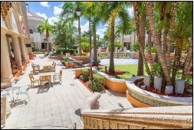
Figure 1: Amenities incorporated at Village Green
Shopping as the Gulfstream Park
The development of a store carrying couture would be a good fit for the existing retail and potential clientele at the Gulfstream Park. This phenomenon may be attributed to the fact that the design embedded in the project, places it at a vantage point by making it a one-stop facility that caters for most of the shopping needs of individuals. The development of pedestrian amenities facilitates ease of shopping especially for fashion fanatics who gravitate towards the exceptional design and taste that is characteristic of couture. Moreover, the Gulfstream Park's fundamental purpose is to provide an all-inclusive social interaction center for family members comprising of diverse demographics thus the unique nature of a fashion house will resonate well with people who tour the project.
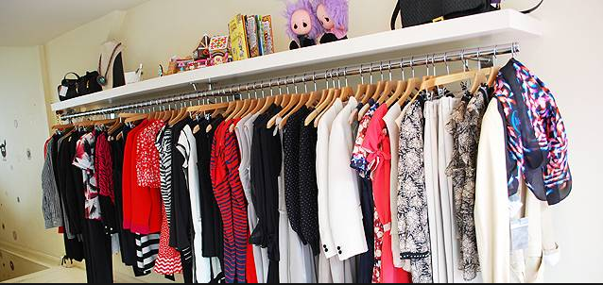
Figure 2: A model couture fashion line at Gulfstream Park
Sales Floor Area
The section of the project that houses the Craft and Barrel retail store may be categorised as a prime sales floor in the sense that the franchise has endeavoured to develop a personalised relationship with its customers by sharing first-hand information about the products it sells. Moreover, Craft and Barrel have successfully managed to create a symbiotic relationship with the designers, artisans, and customers leading to the development of unique products that may be bought at an affordable price.
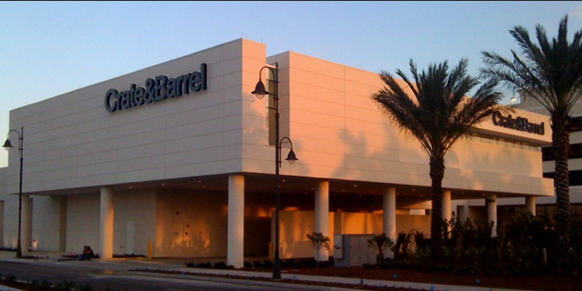
Figure 3: Image illustrating a section of Crate & Barrel Retail Store
The Sirona Fine Art depicts an upscale art gallery that prides itself on the development of unique sculptures and paintings. It may be categorized as belonging to the average sales floor area as it appeals to a niche market of art enthusiasts who have a passion for collecting elegant pieces of art that enhance their lives and homes.
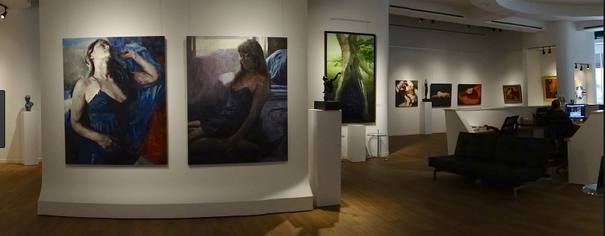
Figure 4: Art pieces at Sirona Fine Art gallery.
The Texas de Brazil may be categorised as belonging to the non-productive retail store in the sense that it appeals only to a few steak lovers who find delight in foreign cuisine. Moreover, the meals at this restaurant tend to be pricy owing to the authenticity of combining Brazilian-American menus that are usually accompanied by exceptional wines. 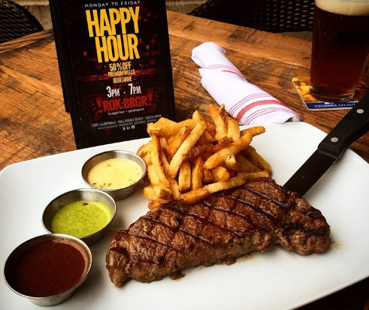
Figure 5: A meal at Texas de Brazil
Concept Statement
The inspirational piece was selected as it is comprised of a unique and intricate design patterns in regard to the materials, fabrics and accessories used. Moreover, piece may be defined as being artistic and free-flowing leading to the impression of an authentic and personalised design that takes into accounts the exceptional themes presented by the designer. The piece may be seen as a model that may influence the interior design process from the conceptualisation stages to the completion of the project that adds value to the community. Moreover, the piece demonstrates the need for paying close attention to the entire design and decorative process in a bid to develop a product that is appealing to the eye. The piece also employs the use of sophistication which contributes to the distinctiveness of the product which makes it stand out from the rest. Without a doubt, the fusion of an exceptional and sophisticated model with interior design structures is bound to attract positive comments due to its inspiration and visual appeal.

Works Cited
FGBC. Village at Gulfstream Park. http://floridagreenbuilding.org/index.cfm/go/public.certifiedProject/projectID/10418. Accessed 24 October 2017
Zeunert, Joshua. Landscape Architecture and Environmental Sustainability: Creating Positive Change Through Design. Bloomsbury Publishing, 2017.

